*Meme Review: Dead or Alive?*

Abir Rahman

*Dept. of Computer Science and Engineering*

*North South University*

Dhaka, Bangladesh

abir.rahman01@northsouth.edu

Jawad Aziz Khan  
*Dept. of Computer Science and Engineering*  
*North South University  
Dhaka, Bangladesh*  
jawad.khan1@northsouth.edu

Taufiq Rahman  
*Dept. of Computer Science and Engineering*  
*North South University  
Dhaka, Bangladesh*  
rahman.taufiqur@northsouth.edu

***Abstract*—*In an era where internet community has become a staple, meme culture has seemingly dominated the populous’ preference for expression in, everywhere from, forums to social media and has even gotten as far as influencing big companies to use memes to market their brand. But their short lifespan makes them an ever changing lexicon. Teaching a machine to estimate the timely relevance of a given meme could prove to be a novel method of predicting human behavior.***

***Keywords—memes, machine learning, marketing, predictions***

# Introduction

Memes are a modern cultural phenomena that helps this generation express a vast array of sentiments albeit having short relevance life spans.

Our project is a classification problem where meme images are to be recognized by :-

* Running supervised model training
* Grouping images according to visual similarity and sorted by the month/year that it was popular
* Which can then be linearly regressed to predict what type of meme might gain popularity / be relevant

# Motivation

With a growing number of social media platforms and social media influencers, feedback on content created by content creators have become crucial. Getting feedback after publishing is already done nowadays but what if there was a way to provide feedback based on a working formula even before the content is placed in front of the world?

Data is key in this ambition. With businesses racing to make their products and services ‘viral’. The internet is scattered with such data that already exists. Some ventures have become massive success stories and others have flopped beyond recovery. This massive dataset that already exists with machine learning algorithms can be turned into a tool useful to many of the modern day content creators.

The internet is a massive ocean of digital data starting from important emails to cat videos. The pioneers of the internet could not have predicted the popularity of the term ‘meme’ to be taking over the throne. Humans have changed over time adjusting to their surroundings and have found several ways to entertain themselves. Memes have become a multi-million dollar entertainment platform where businesses such as ‘9GAG’ have made a fortune. They are not only a matter of entertainment but rather mainstream corporations have started using them as marketing tools to reach this new millennial generation. With this motivation, we plan to create a way to help this new generation of ‘meme’ creators to find the best outreach for their content.

# Related Work

Work related to internet memes and their statistics is found in the areas of web intelligence and social network analysis. However work related to predicting user response to memes are scarce and hard to come by.

Work in the separate fields are more widely available, such as use of neural net algorithms to predict responses of image involved parameters or social studies into why memes have become such a popular tool in the social media marketing scheme.

## Marketing with Twitter: Challenges and Opportunities

The uprising of social media platforms have allowed marketers to reach a new height of audience engagement. Twitter in specific is one of the largest and fastest growing platforms in recent times accounting for about 255 million monthly active users (Twitter, 2014a). This has lead to the collection of user centric data that is highly valuable in designing marketing ventures.

This journal pointed out that specific features may have more overall effect in the final decision of a user response.For example it talked about how the chances of retweets differed depending on whether brands provided public or private replies. Keeping this in mind, we shortlisted our metadata to provide inputs such as Upvotes, Dates and Author Details. In our case this seemed provide the best relations and explanations to our data.

## A Study of Meme Propagation

`This paper talks about how memes gain momentum and then loses popularity. The paper also studied how the category of the meme affected its lifetime on the internet. Meme data was categorized and then put up against a time cluster. It was seen that political memes were more popular than general ones at that particular time due to the presidential elections of the United States Of America. This showed how the surroundings of the current positioning of time affected the lifetime of the meme. In accordance we also categorized our data and hope to find relations with them with date and time of its publishing.

## Going Deeper with Convolutions

As most image centric machine learning projects go, for substantial results the use of neural networks are prevalent. This decade, the superpower of machine learnt computer vision is definitely Google and their epitome of image data. Their first iteration of this was the GoogLeNet after which they improved on the network architecture and codenamed it Inception.

The Inception is a Deep Convolutional Neural Network that aims to "go deeper" in terms of both it's network layer depth and an optimized matrix processing architecture. The paper "Going Deeper with Convolutions" by C. Szegedy explains how Inception's dataflow architecture works. Basically it takes in a small array of large matrices. Then as the network processes the weights it slowly decreases the matrix size but distributes them along a larger array. This enables the images fed into the neural net to be divided up into chunks and hence maintain as much of its recognizable features as possible. As seen from the table the first layer takes in 64 chunks of 112 x 112 input. And these chunks can all be arranged to fit a 672 x 672 image. Another advantage of the Incepetion Net is the usage of multiple forward fed softmax outputs that refine the loss logarithmically of the later nodes.

This is important knowledge as among neural networks Inception is one of the most performant as seen in the 2014 ImageNet Large-Scale Visual Recognition Challenge, which it won 1st place in both classification and detection, having an error of only 6.7%.

*E. Visualizing Data with TSNE*

TSNE is a popular mapping algorithm that is best suited for data that is encompassed on a higher number of dimensions than observable. Albeit TSNE is used for mapping, it's real purpose is Dimensionality Reduction. The paper "Visualizing Data using TSNE" by Laurens van der Maaten that explains how TSNE uses the T Distribution function as a baseline to calculate the each object's nearest neighbor. That is done by randomly traversing a graph net of least euclidean distant points representing other objects. Then embedding that neighbor with 2D or 3D vector space coordinates corresponding to their features and then placing them near the previous centroid. Hence the name T-Distributed Stochastic Neighbor Embedding.

The reason TSNE is considered relevant even now despite being a decade old is due to the fact that it's algorithm is optimized to work with high dimensional data by representing the many features as a vector hence preserving the non-linear characteristics of the data. It can be observed that once the algorithm run, the clusters formed are usually very dense and maintains a strict uniform distance between other clusters, making it a reasonable choice for easily solving classification problems.

# Data Source

## Data Source

The data is composed of more than 3,000 meme images of varying resolutions and types downloaded from Reddit. An attached JSON Array file containing the images’ respective metadata is also found with the dataset. The JSON metadata contains vital information like title, time published, number of upvotes and downvotes. The image dataset and its data were collected from Kaggle.com, uploaded by user sayangoswami on 17th April 2018.

## Pre - processing

The 3,000 images come in varying resolutions so a resize preprocess is necessary for more accurate model training. Although that might cause stretching it will result in more easily comparable negatives that can be fed to the network. Finally the accompanying JSON metadata provides valuable information. Corresponding filenames are included in the metadata as random alphanumeric strings that should be renamed and indexed by some sorting method. And the time provided is in the UTC (Coordinated Universal Time) time standard and is in a UNIX-based timestamp which needs to be converted to an easily readable dd/mm/yy format.

## Data Visualization

## Data visualization was done with the open source data visualization platform ‘Tableau Public’ and a python script that uses a U-map algorithm to project the images onto an HTML canvas running webGL

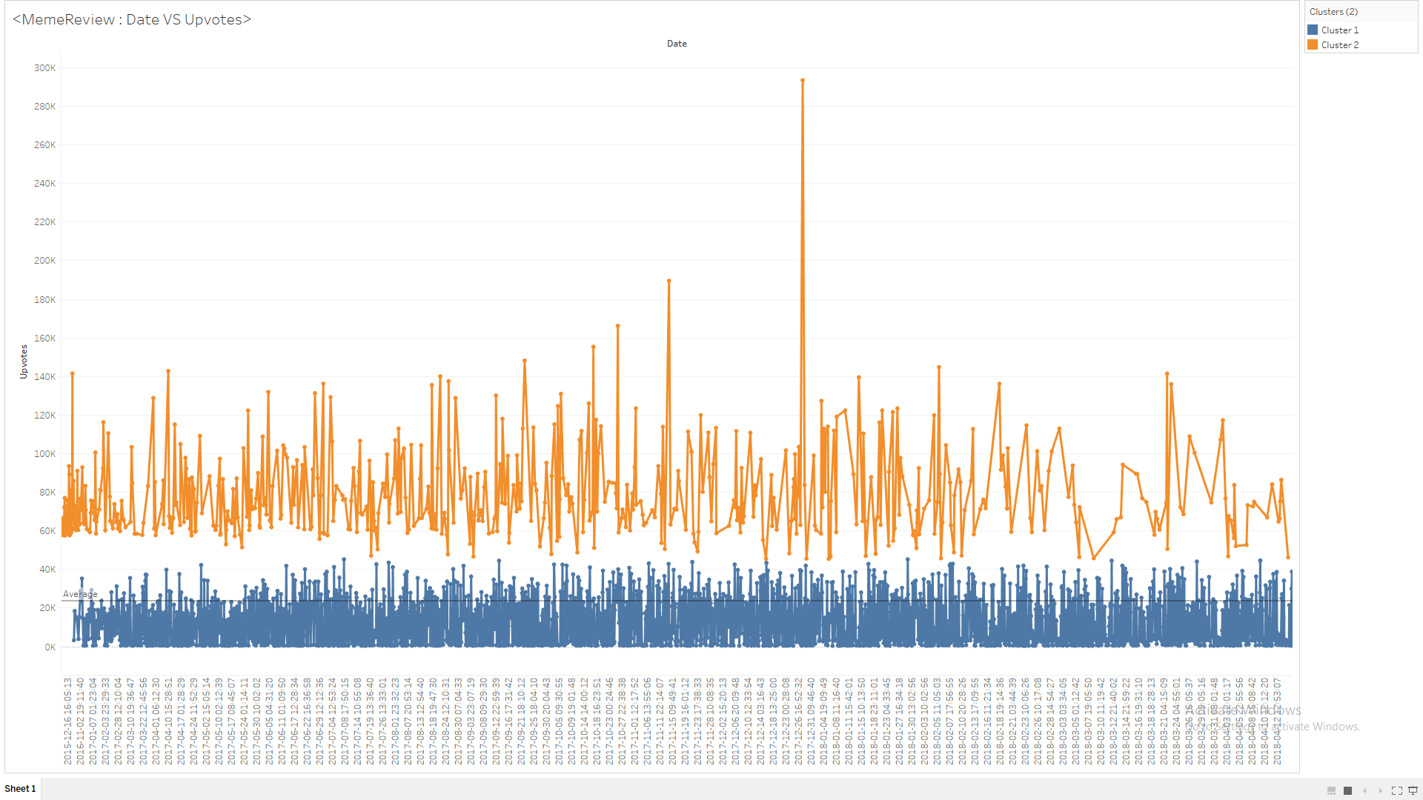

1. Upvotes vs Date published

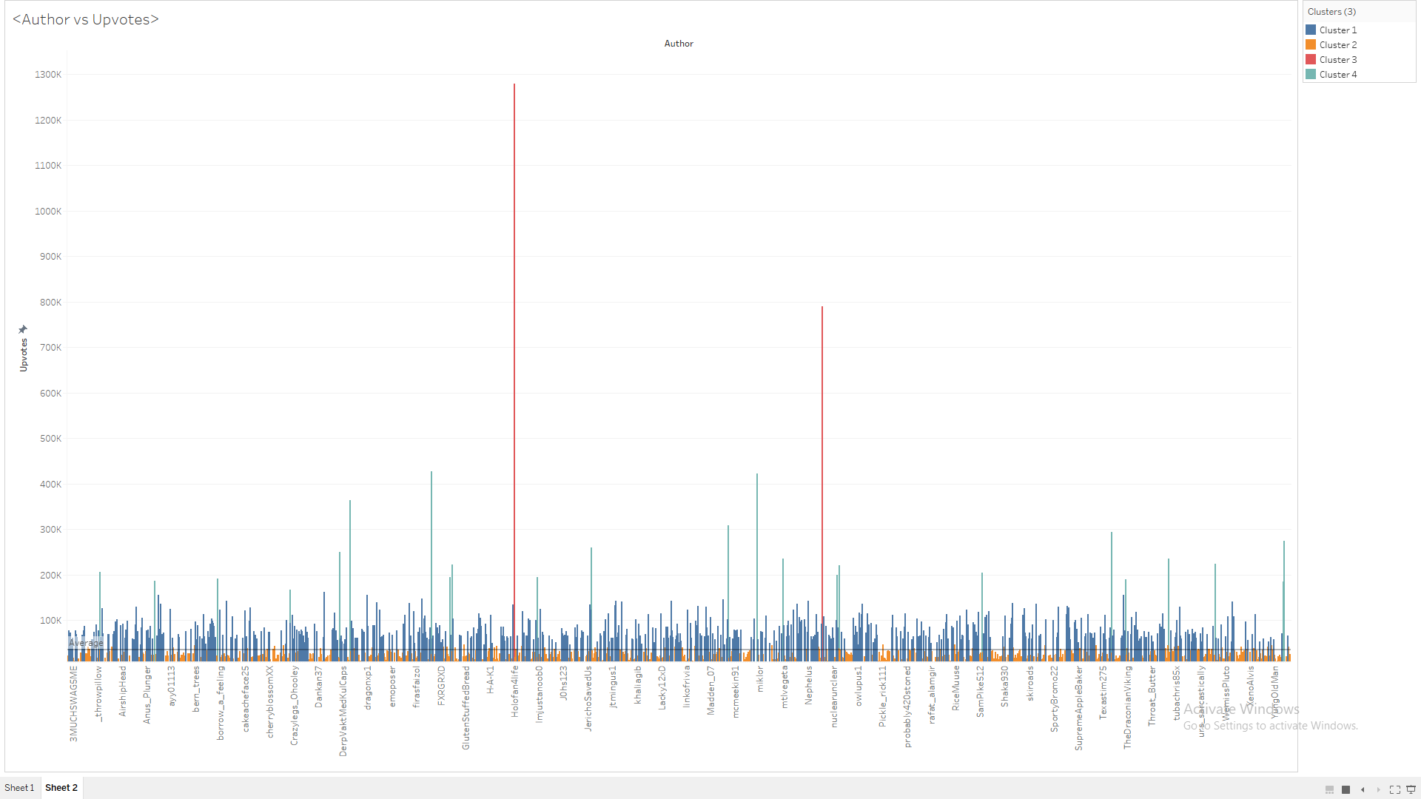

Fig. 2. Upvotes vs Author

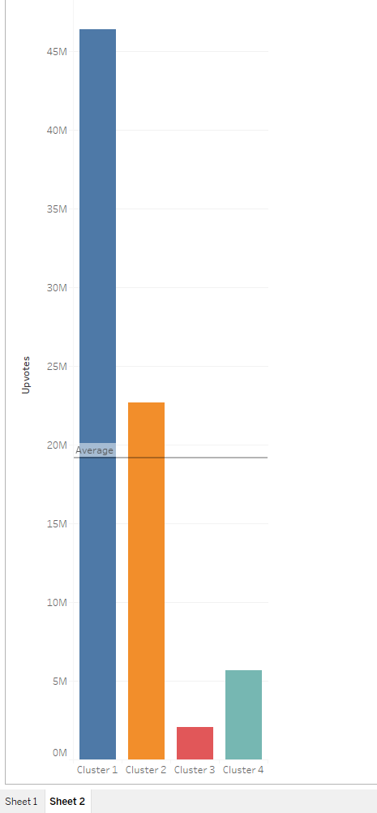

Fig. 3. Author Clusters

Fig. 4. UMAP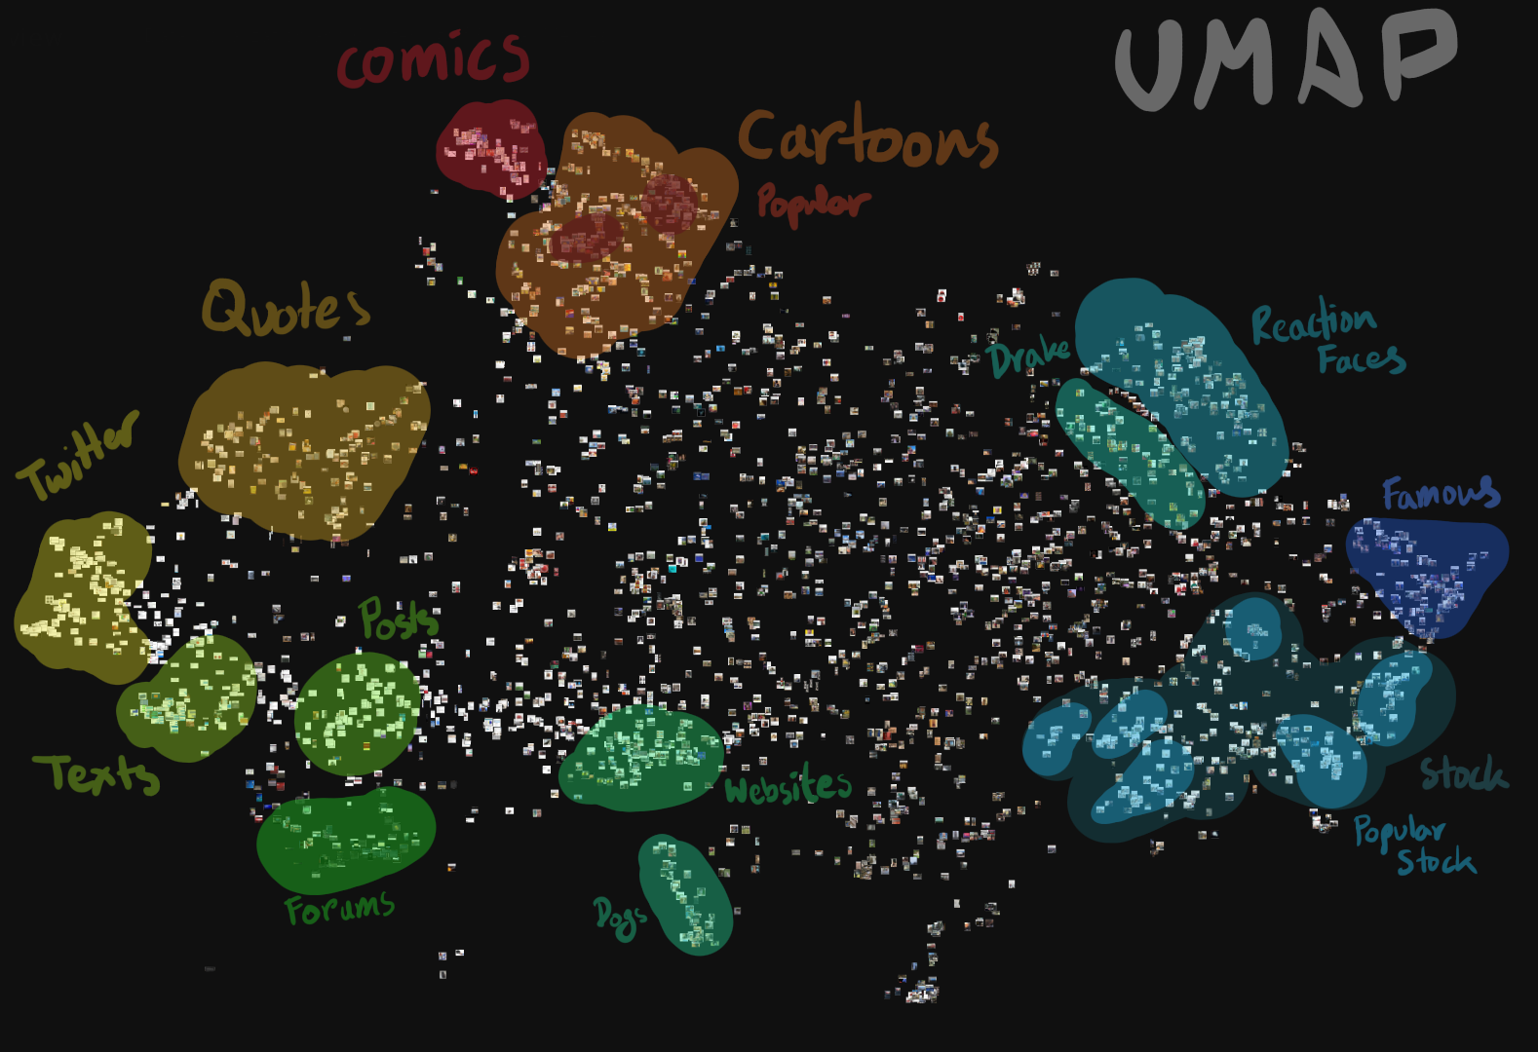

The data visualizations acquired from the metadata of the memes in our dataset showed some interesting outputs. When correlations between Upvotes and Dates (Fig,1) were set, it was seen that memes were increasingly popular during the end of 2016 however the rate of successful memes declined throughout 2017. On the other hand When Upvotes were paired with the author(Fig.2, Fig.3), and interesting clustering was seen. The authors were divided into four categories. Upon further inspection it was found that there were four types of people making memes. Cluster 1 showed people with memes that had upvotes ranging from 40000 to 80000. These people were the ‘above average’ meme creators. Cluster 2 showed people with memes with upvotes ranging from 10000 to 50000. These people were deemed the ‘causal’ meme creators. Cluster 3 showed people who had very less upvotes in each individual meme but made numerous memes, following a somewhat quantity over quality pattern. Lastly cluster 4, had people who made original memes and in low quantities but were immensely popular. These class of people were deemed the ‘elite meme creators’.

# Algorithms

##### As this is an image classification problem we have considered taking advantage of the OpenCV platform for traditional computer vision but that proved to be too challenging as image analysis requires large datasets and very intense computation, best powered by a GPU. Hence finally TensorFlow **3** is preferred as various Convolutional Neural Networks can be constructed with relative ease and has GPU support to power heavy computes. Image classification is best done by Neural Networks or Deep Learning and hence that is what this project will attempt. Widely used networks are well implemented by TensorFlow thus the 3 Network algorithms below are planned to be implemented:

* Inception v3, Google’s state of the art Image Recognition Convolutional Neural Network
* AlexNet, a CNN developed by Alex krizhevsky, Ilya Sutskever and Geoffrey Hinton for the 2012 ImageNet Challenge. It is built to run on CUDA GPUs
* VGGnet, is a deep convolutional network developed by Oxford's renowned Visual Geometry Group in 2013

##### Acknowledgment

We would like to acknowledge all the team members involved in the project. We would also like thank our peers, Ishfaq and Shabbir for their valuable insights into CNN and Neural Networks.

##### References

1. A Study of Meme Propagation: Statistics, Rates, Authorities, and Spread - *Onkar Dalal, Deepa Mahajan, Ilana Segall, Meghana Vishvanath*
2. Reddit Memes Dataset: *A collection of the latest memes from the various meme subreddits - Sayan Goswami*
3. Is Google Tensorflow Object Detection API the Easiest Way to Implement Image Recognition? - *Priyanka Kochhar, Deep Learning Consultant,kdnuggets.com https://www.tensorflow.org/tutorials/images/image_recognition*
4. Object Recognition with Google’s Convolutional Neural Networks: Classifying Images Using Google’s Pre-Trained Inception CNN Models - *William Koehrsen, medium.com*
5. ImageNet Classification with Deep Convolutional Neural Networks - *Alex Krizhevsky, Ilya Sutskever and Geoffrey Hinton, UofT NIPS*
6. Very Deep Convolutional Networks For Large-scale Image Recognition - *Karen Simonyan & Andrew Zisserman, Oxford arXiv and Google DeepMind*
7. M. Young, The Technical Writer’s Handbook. Mill Valley, CA: University Science, 1989.
8. Going Deeper with Convolutions, *Christian Szegedy, 17 Sep 2014, Cornell University ArXiv*
9. Visualizing Data using TSNE, *Laurens van der Maaten, 9th of November 2008,* The Journal of Machine Learning Research
10. A Study of Meme Propagation, *Onkar Dalal, Deepa Mahajan, llana Segall*
11. Marketing with Twitter: Challenges and Opportunities, *Alena Soboleva, Suzan Burton, Aila Khan, Chapter - May 2015*
12. Insights into Internet Memes, *Christian Bauckhage, Germany*